Practical 5
Question:
Implement a producer-consumer communication system using anonymous pipes where the parent process generates data and the child process consumes it. Measure the communication efficiency.
Code:
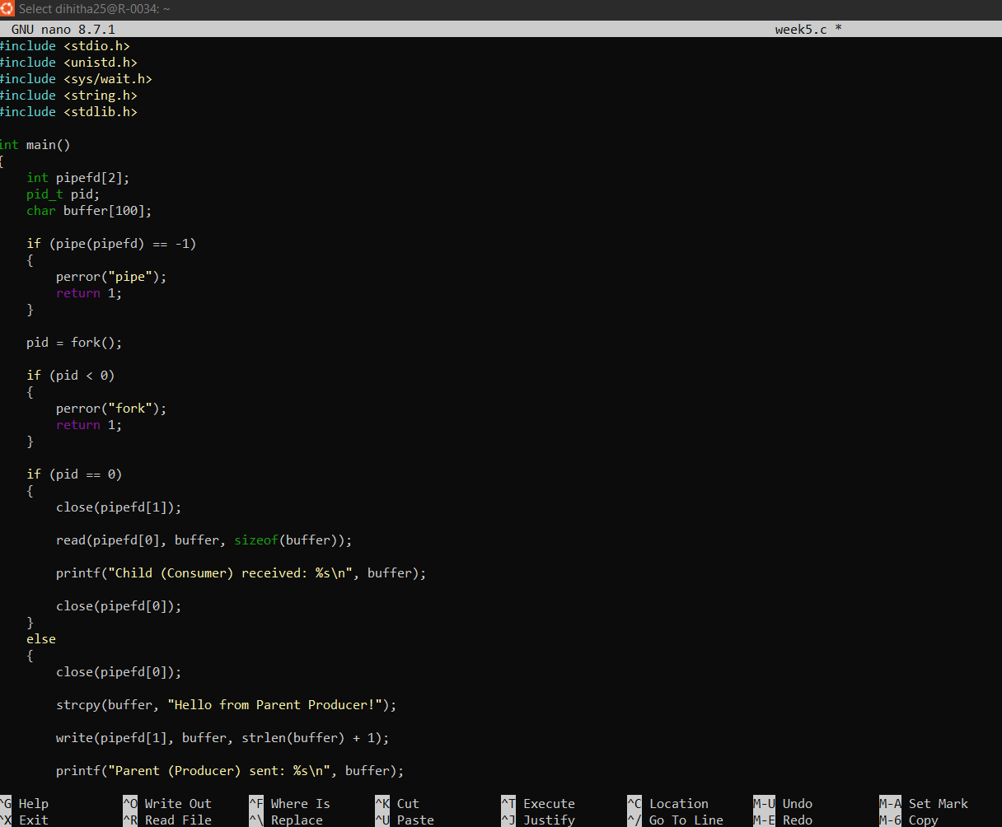
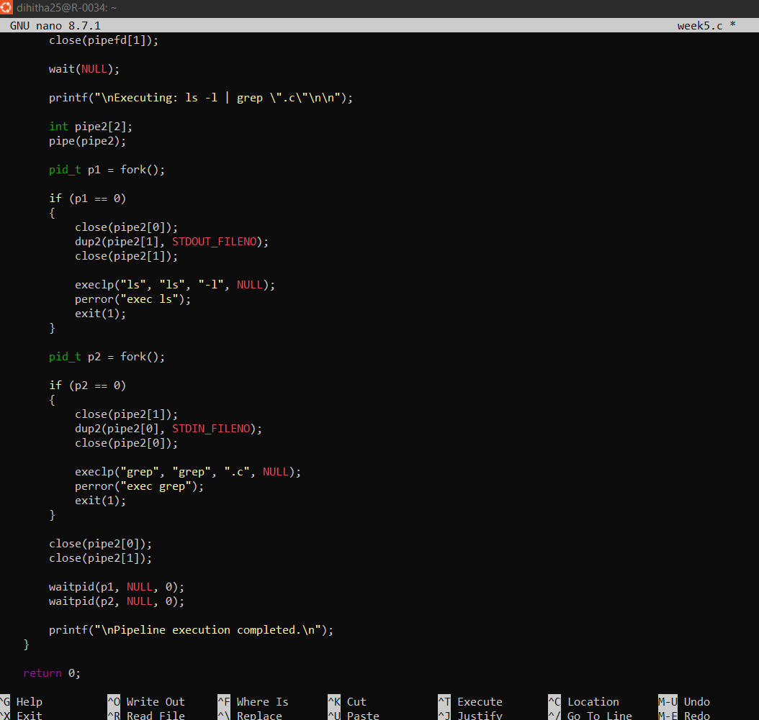
Output:
